IIT Jodhpur

PGD DE

Virtual Machine Creation using GCP

Virtualization and Cloud Computing

Swatantra Yadav

IITJ

**Subject: Virtualization and Cloud Computing Assignment No: II**

**Submitted By: Swatantra Yadav Student Id: G24AI1065**

**E-mail:**[**g24ai1065@iitj.ac.in**](mailto:g24ai1065@iitj.ac.in)

**Institute: Indian Institute of Technology Jodhpur Submitted To: Professor, Dr. Sumit Karla**

# Introduction

This report outlines the steps taken to set up a Virtual Machine (VM) on Google Cloud Platform (GCP), configure auto-scaling policies based on CPU utilization, and implement security measures such as IAM roles and firewall rules. The goal is to demonstrate the ability to leverage GCP's infrastructure for scalable and secure deployments.

# Creating a VM Instance on GCP

## Sign in to GCP Console:

* + - Navigate to <https://console.cloud.google.com/>
    - Ensure you have the necessary permissions to create a VM instance.

## Create a New VM Instance:

* + - Go to the Compute Engine section.
    - Click on VM instances => Create Instance.
    - Provide the following details:
      * Name: Specify a unique name for the instance.
      * Region &Zone: Select the preferred location.
      * Machine Type: Choose the appropriate CPU and memory configuration.
      * Boot Disk: Select an operating system (e.g., Ubuntu , Debian, or Windows Server).
      * Firewall Rules: Enable HTTP/HTTPS traffic required.
    - Click Create to launch the VM instance.

# Configuring Auto-Scaling Policies

## Create an Instance Template:

* + - Navigate to Compute Engine > Instance Templates > Create Instance Template.
    - Configure machine type, boot disk, and start up script as per your requirements.

## Create a Managed Instance Group (MIG):

* + - Go to Compute Engine > Instance Groups > Create Instance Group.
    - Select Managed instance group.
    - Choose the instance template created earlier.
    - Define Auto scaling policies:
      * Enable auto scaling.
      * Set up metrics such as CPU utilization (e.g., increase instances when CPU usage exceeds 70%).
      * Define minimum and maximum instances to ensure scalability limits.
    - Click Create.

# Implementing Security Measures

## Setting up IAM Roles

1. Navigate to IAM & Admin > IAM.
2. Click Add to assign roles to users or service accounts.
3. Select the appropriate roles such as:
   * Compute Viewer(Read-Only Access)
   * Compute Admin(Full Access)
   * Custom roles based on specific permissions.
4. Click Save to apply changes.

## Configuring Firewall Rules

1. Navigate to VPC Network> Firewall>Create Firewall Rule.
2. Provide the following details:
   * Name: Unique firewall rule name.
   * Direction: Choose Ingress (incoming traffic) or Egress (outgoing traffic).
   * Targets: Specify whether the rule applies to all instances or specific tags.
   * Source/Destination: Define the IP range (e.g., allow only internal traffic 10.0.0.0/16).
   * Protocol and Ports: Allow or deny traffic for specific protocols (e.g., TCP: 22 for SSH, TCP: 80 for HTTP).
3. Click Create to enforce the rule.

# Architecture Design

Below is a high-level overview of the GCP architecture: Diagram Overview:

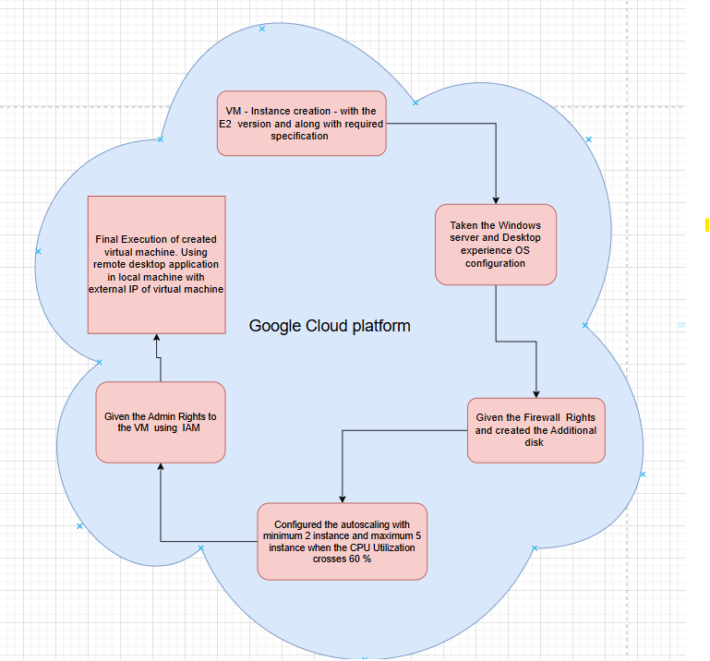

* VM Instance: A virtual machine hosted in GCP.
* Managed Instance Group (MIG): Handles auto-scaling of VMs based on CPU utilization.
* Load Balancer (Optional):Distributes traffic among instances.
* Firewall Rules: Defines in bound and out bound traffic control.
* IAM Roles: Restricts access to specific users or service accounts.

# Conclusion

By following these steps, you can successfully deploy a virtual machine in GCP, implement auto-scaling based on work load demands, and en forces security measures to protect the infrastructure. This setup ensures efficient resource utilization and robust security control in a cloud environment.

1. **REFERENCES**

Compute Engine (VMs) Overview <https://cloud.google.com/compute/docs>

Managed Instance Groups and Auto-Scaling <https://cloud.google.com/compute/docs/instance-groups><https://cloud.google.com/compute/docs/autoscaler>

Google Cloud Load Balancer (If used) <https://cloud.google.com/load-balancing/docs>

Firewall Rules in GCP <https://cloud.google.com/vpc/docs/firewalls>

IAM Roles and Permissions <https://cloud.google.com/iam/docs/roles-overview>

## .

### GitHub Link: https://github.com/ydv2027/auto-scaling-vcc

### Video Link:

### 

### Thank You!!!

### Swatantra Yadav